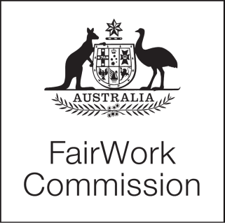
[2020] FWC 6411

STATEMENT
Fair Work Act 2009
s.285—Annual wage reviews to be conducted

Annual Wage Review 2020–21
(C2021/1)
JUSTICE ROSS, PRESIDENT | MELBOURNE, 27 NOVEMBER 2020

RESEARCH PROGRAM

- On 29 October 2020, a Statement was issued on the draft research program for the Annual Wage Review 2020–21 (2020–21 Review). Submissions regarding the draft research program were sought by Thursday 12 November 2020. Two submissions were received and published on the Fair Work Commission’s website.

- The ACTU and Ai Group provided comments on the draft research program. No submission was received seeking a change to the draft research program.

- The report titled ‘An assessment of the economic effects of COVID-19’ will be undertaken by Professor Jeff Borland from the University of Melbourne. The report will be first published in late December and updated periodically during the course of the 2020–21 Review.

- The draft research program, as published on 29 October 2020, is now confirmed.

PRESIDENT

Printed by authority of the Commonwealth Government Printer

<PR724971>

[2020] FWC 5779

