|  |
| --- |
| [2020] FWC 5430 |
| STATEMENT |

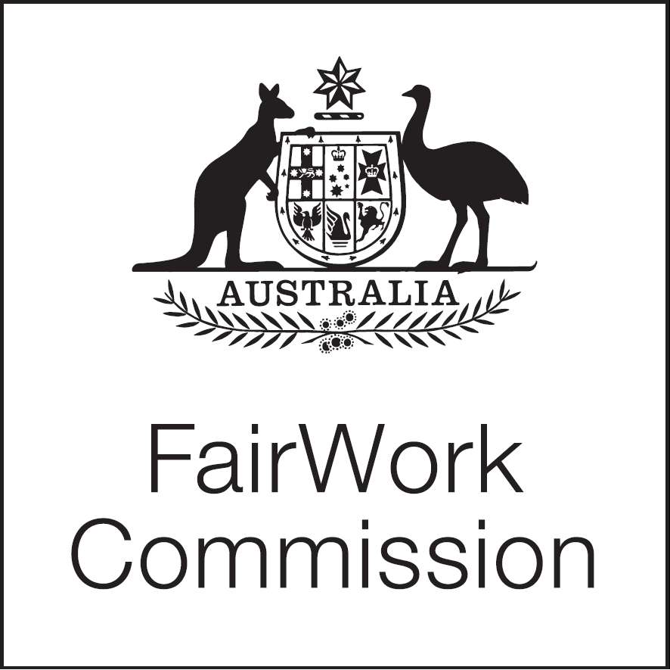Fair Work Act 2009

s.285—Annual wage review

Annual Wage Review 2020–21

(C2021/1)

|  |  |
| --- | --- |
| Justice ross, president | MELBOURNE, 12 OCTOBER 2020 |

TIMETABLE

1. On Thursday 17 September 2020, a [Statement](https://www.fwc.gov.au/documents/wage-reviews/2020-21/decisions/2020fwc5012.docx) was issued on the draft timetable for the *Annual Wage Review 2020–21*.[1][1] Two submissions were received and published on the Fair Work Commission’s [website](https://www.fwc.gov.au/awards-agreements/minimum-wages-conditions/annual-wage-reviews/annual-wage-review-2020-21/decisions). The [Australian Council of Trade Unions](https://www.fwc.gov.au/documents/wage-reviews/2020-21/actusub.pdf) (ACTU) proposed that an additional 7 days be allowed for reply submissions. The [Australian Industry Group](https://www.fwc.gov.au/documents/wage-reviews/2020-21/aigroupsub.pdf) did not have any concerns regarding the draft timetable or ACTU’s proposal for an extension of time for reply submissions.
2. The draft timetable has been adjusted to allow for an additional 7 days for reply submissions. The timetable provided at Attachment A is confirmed.

PRESIDENT

Printed by authority of the Commonwealth Government Printer

<PR723482>

|  |
| --- |
| Attachment A  Annual Wage Review 2020–21 —Draft Timetable |

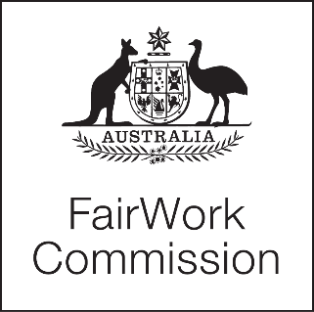

|  |  |
| --- | --- |
| **Date** | **Event** |
| 26 March 2021  2 April–5 April 2021 | Closing date for lodging submissions  Easter |
| 23 April 2021 | Closing date for lodging reply submissions and any submissions relating to data or research published after 26 March 2021 |
| 7 May 2021 | Closing date for expressions of interest in taking part in consultations |
| 14 May 2021* | Closing date for lodging supplementary submissions relating to data or research published after 23 April 2021 and/or post-Budget submissions |
| 19 May 2021^ | Consultations |
| 4 June 2021# | Closing date for lodging submissions regarding the National Accounts March quarter 2021 |
| 8 June 2021 | Closing date for lodging reply submissions regarding the National Accounts March quarter 2021 |

* This date has been set on the assumption that the Budget for 2021–22 will be handed down on the second Tuesday of May, 11 May 2021, consistent with usual practice.

^ Format and location to be determined.

# This date has been set on the assumption that the ABS National Accounts data are released on the first Wednesday of June, 2 June 2021, consistent with usual practice.

|  |
| --- |
|  |

1. [1] [2020] FWC 5012.